Trending:
Doing vs. Idling
Sermon Notes for June 17th, 2018

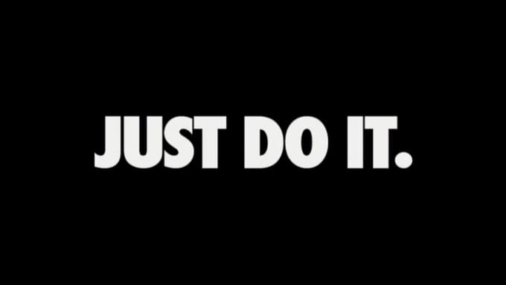

Play youtube video (https://www.youtube.com/watch?v=ZXsQAXx_ao0)

James 1:22-25
²² Do not merely listen to the word, and so deceive yourselves. Do what it says.²³ Anyone who listens to the word but does not do what it says is like someone who looks at his face in a mirror ²⁴ and, after looking at himself, goes away and immediately forgets what he looks like. ²⁵ But whoever looks intently into the perfect law that gives freedom, and continues in it—not forgetting what they have heard, but doing it—they will be blessed in what they do.

Isaiah 55:11
¹¹ so is my word that goes out from my mouth: It will not return to me empty, but will accomplish what I desire and achieve the purpose for which I sent it.

Do what it says, change the world

1 John 3:11, 16-19
¹¹ For this is the message you heard from the beginning: We should love one another.
¹⁶ This is how we know what love is: Jesus Christ laid down his life for us. And we ought to lay down our lives for our brothers and sisters. ¹⁷ If anyone has material possessions and sees a brother or sister in need but has no pity on them, how can the love of God be in that person? ¹⁸ Dear children, let us not love with words or speech but with actions and in truth. ¹⁹ This is how we know that we belong to the truth and how we set our hearts at rest in his presence:

Babylon Bee Screen Shots

1 John 4:9-10
⁹ This is how God showed his love among us: He sent his one and only Son into the world that we might live through him. ¹⁰ This is love: not that we loved God, but that he loved us and sent his Son as an atoning sacrifice for our sins.

1 John 4:11-12
¹¹ Dear friends, since God so loved us, we also ought to love one another. ¹² No one has ever seen God; but if we love one another, God lives in us and his love is made complete in us.

1 John 4:19
¹⁹ We love because he first loved us.

Next Steps:
1.) Get ready to be courageous (Doing what the word says and loving the world)
2.) Be committed to hearing/doing the word of God (reading plan)
3.) Approach the Text with humility, look at the mirror.
4.) Get ready to wrestle through what application actually looks like.
5.) The Word of God will change you if you allow it. It will also change the world!

Do what it says, change the world

